aiOS Project Vision & Architecture
Version: Draft 0.1
Status: Community Proposal
License: MIT
Project Type: Open Source

Introduction
aiOS is an open-source initiative to build a lightweight, AI-first operating system for local artificial intelligence workloads.
The goal is not simply to create another Linux distribution, but to build a complete AI platform that transforms a minimal Linux installation into a dedicated environment optimized for running large language models (LLMs), multimodal models, AI agents, and future local AI workloads.
Instead of installing dozens of unrelated tools and manually configuring GPU drivers, inference runtimes, Docker, monitoring systems, and dashboards, aiOS aims to provide a unified platform where everything works together out of the box.

Why This Project Exists
Current operating systems were designed for general-purpose computing.
They serve desktops, laptops, development workstations, web servers, and enterprise infrastructure.
Artificial Intelligence introduces a different workload.
Running local AI models requires:
- GPU acceleration
- Efficient memory management
- Large model storage
- Runtime orchestration
- Continuous monitoring
- Model lifecycle management
- Multiple inference engines
- Containerized services
Today, developers spend significant time configuring these components manually.
aiOS aims to simplify this experience.

Project Philosophy
The project is guided by several principles:
AI First
Every design decision should prioritize AI workloads.

Lightweight
Only install and run what is necessary.
Avoid unnecessary desktop software and background services.

Modular
Every major component should be replaceable.
Examples include:
- Runtime engines
- Authentication providers
- Monitoring systems
- Storage backends

Open
The project will remain open source.
Architecture discussions, feature proposals, and implementation decisions should happen publicly.

Community Driven
No single developer should become a bottleneck.
The architecture should encourage independent contributors to work on different components simultaneously.

What aiOS Is
aiOS is intended to become a complete AI operating platform including:
- AI Runtime Manager
- GPU Resource Manager
- Model Manager
- AI Scheduler
- AI Router
- REST API
- Web Dashboard
- CLI
- Plugin System
- Monitoring Stack
What aiOS Is NOT
aiOS is not intended to be:
- another desktop Linux distribution
- a replacement for Ubuntu or Debian
- a general-purpose operating system
- a machine learning framework
- a cloud service
The focus is local AI infrastructure.
Initial Development Strategy
The project will not begin by building a Linux distribution from scratch.
Instead, development will proceed in stages.
Stage 1
Use Ubuntu Server LTS as the base operating system.
This allows contributors to focus on building AI infrastructure rather than maintaining a Linux distribution.
Stage 2
Develop the aiOS platform.
Major components include:
- CLI
- Core daemon
- REST API
- Dashboard
- Runtime Manager
- Scheduler
- Model Manager
Stage 3
Create an automated installer.
A clean Ubuntu Server installation should become aiOS with a single installation command.
Stage 4
Publish an official aiOS ISO.
The ISO will simply automate installation and configuration of the platform while preserving compatibility with Ubuntu packages.
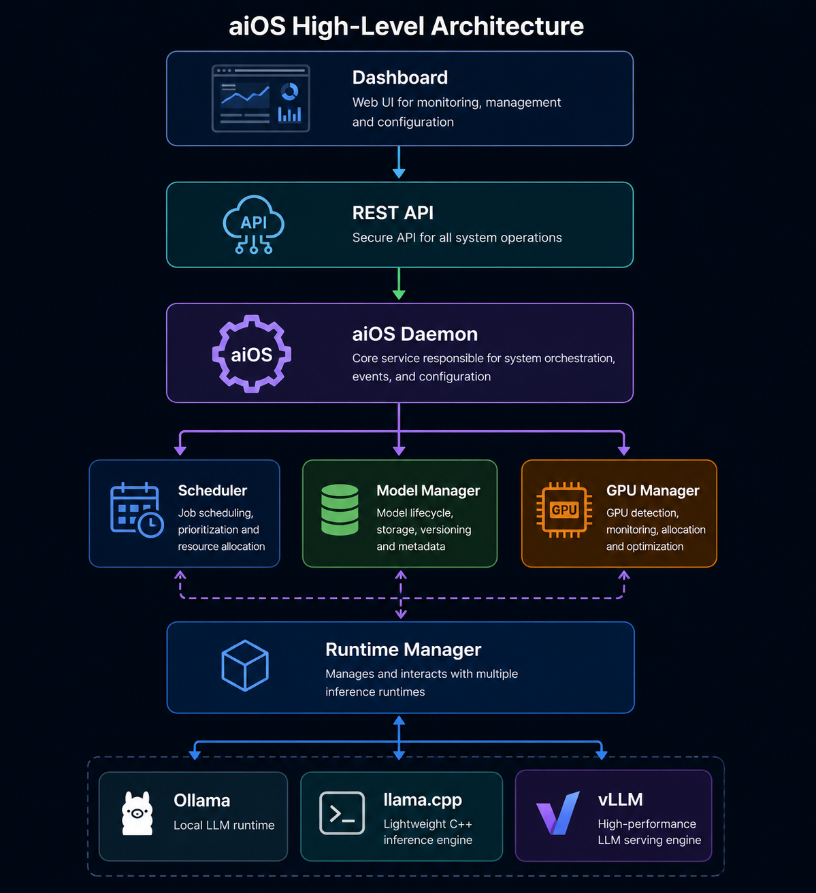

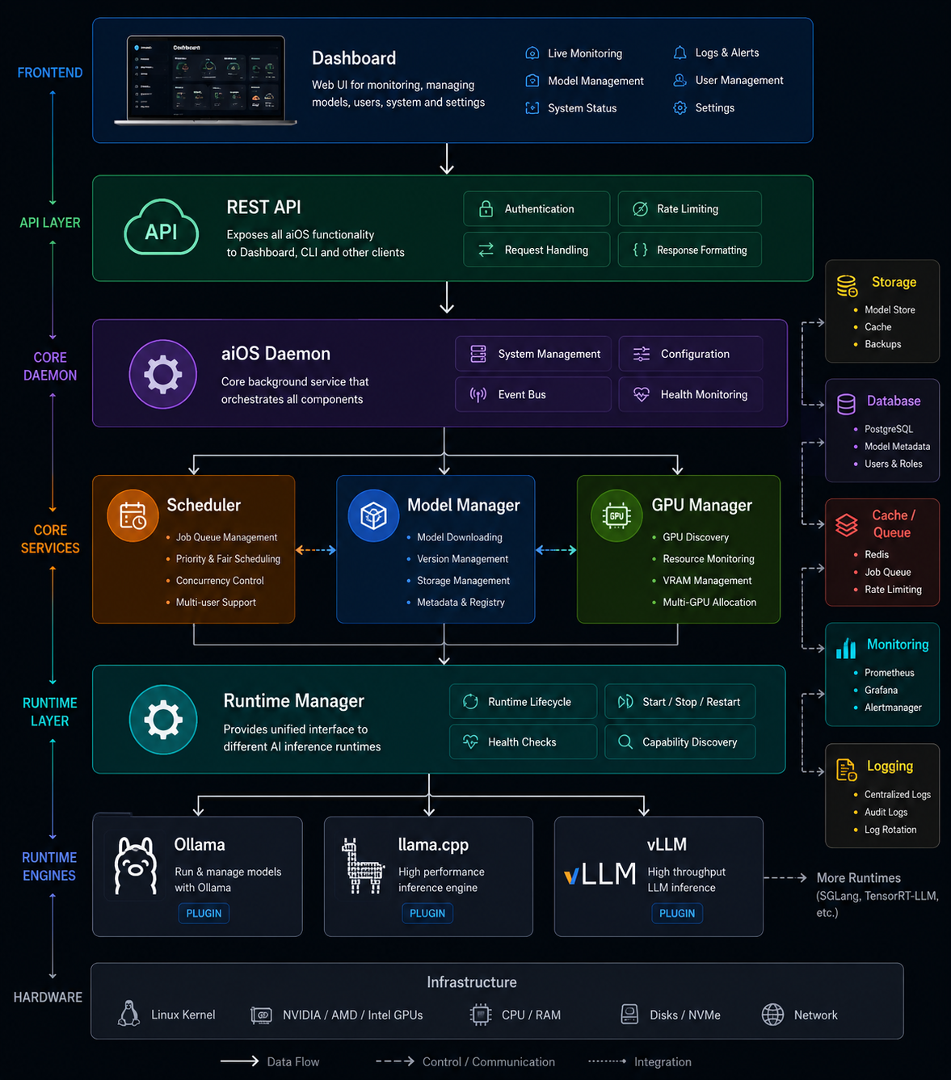
Planned Components
CLI
The CLI should expose all system functionality.
Examples:
aios doctor
aios gpu
aios models
aios install llama3
aios run llama3
aios benchmark

Core Daemon
A background service responsible for:
- hardware detection
- runtime management
- GPU monitoring
- configuration
- events
- scheduling

Runtime Manager
Provide a common interface for different inference engines.
Examples:
- Ollama
- llama.cpp
- vLLM
- SGLang
Future runtimes should be installable as plugins.

Model Manager
Responsible for:
- downloading models
- validating checksums
- organizing storage
- version management
- automatic updates
- metadata

GPU Manager
Responsibilities include:
- GPU detection
- VRAM monitoring
- temperature monitoring
- power monitoring
- multi-GPU allocation
- CUDA and ROCm integration

Scheduler
The scheduler decides:
- which runtime to use
- which GPU to use
- execution priority
- queue management
- concurrent inference

Dashboard
The dashboard should provide:
- live monitoring
- model management
- GPU information
- system metrics
- logs
- updates
- settings

Technologies Under Consideration
Component | Preferred Technology
Base OS | Ubuntu Server LTS
Backend Services | Go
Performance Modules | Rust (optional)
AI Integrations | Python
Dashboard | React + TypeScript
Database | PostgreSQL
Cache | Redis
Containers | Docker
These choices are open for discussion and may evolve as the project matures.

Open Source Contribution Areas
We welcome contributions in many areas, including:
- Linux
- Go
- Rust
- Python
- React
- TypeScript
- Docker
- GPU programming
- CUDA
- ROCm
- Documentation
- UI/UX
- DevOps
- CI/CD
- Security
- Testing
- Benchmarking
Contributors of all experience levels are welcome.

Current Priorities
The project is currently in the planning phase.
Immediate goals include:
- Define the system architecture.
- Design component interfaces.
- Create the CLI.
- Build the core daemon.
- Develop the REST API.
- Build the web dashboard.
- Implement runtime plugins.
- Develop the installer.

Long-Term Vision
The long-term objective is to make aiOS the preferred platform for running local AI infrastructure.
The platform should support:
- home AI servers
- research labs
- startups
- enterprises
- edge AI deployments
- educational environments
Ultimately, users should be able to install aiOS, choose a model, and begin using local AI within minutes-without manually configuring drivers, runtimes, or complex infrastructure.

Join the Project
This project is in its early stages, and the architecture is still evolving.
If you're interested in operating systems, AI infrastructure, GPU computing, distributed systems, web development, or open-source software, your ideas and contributions are welcome.
Whether you contribute code, documentation, design, testing, or simply provide feedback, you can help shape the future of aiOS.

